**Topics in Software Engineering I**

**CSE 350**

Submission Oct 3, 2022 till 10AM.

**Assignment 1                     Marks 10**

# Group Members

# Sameer Ijaz – FA19-BSE-010

# Muhammad Qasim – FA19-BSE-090

# Hajra Afzal – FA19-BSE-038

1. Explore your project and find all options discussed in lecture 2 from Chapter 2. You need to prepare a google doc that highlights the potential issue that your code has. You may identify these issues with the help of
2. Identify deprecated technology or APIs. Just report the diagram

Ans: Java is deprecated as a language for android apps. Newer Cross-platform languages are available for both android and ios app building. These include react native and flutter.

1. Potential issues missing in the documentation but available in the code

Ans: No issues detected.

B) Use PMD to help identify potential coding errors and customize the rules you use to make sure only pertinent rules are applied to your source code.

1. Create & view code issues directly from your editor

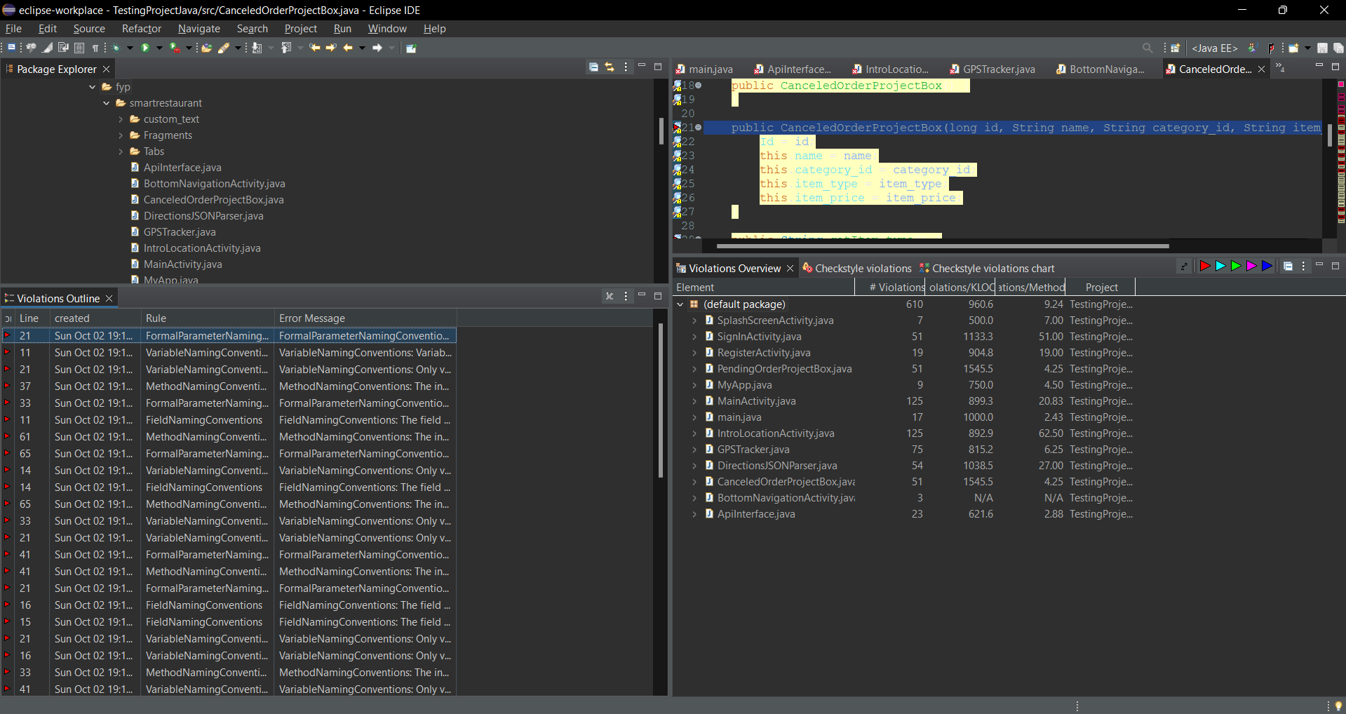

1. Track & prioritize code improvements like technical debt

Due to lack of files in the project I couldn’t identify technical debt due to lack of tests performed on it. Such as Monitor load speeds, test speeds, performance issues.

1. Check your code quality

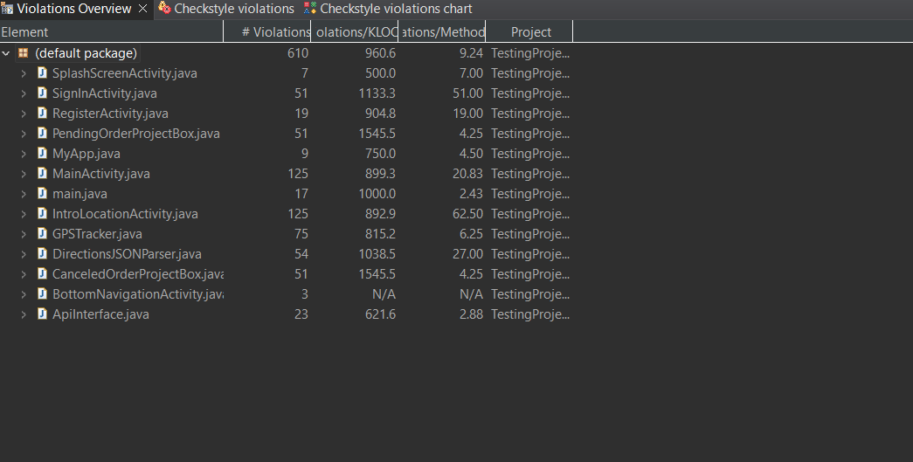

1. Apply at least 3 PMD rules with the help of tool

1. Generate the Abstract Syntax Tree of your source code suing PMD

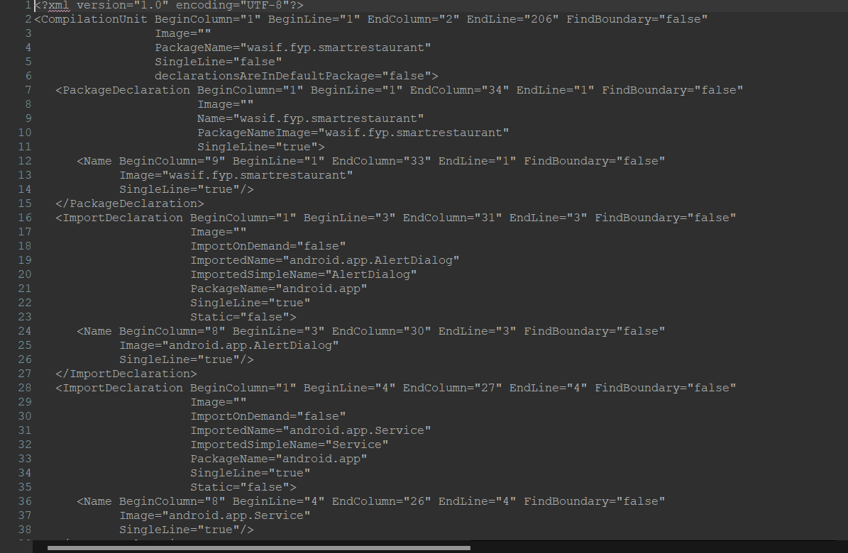

3) Use the Check Style tool to review your code. At least apply 2 rules on your code using Checkstyle

